1. Project Description
The Bank of Patagonia Financial System Database is meticulously designed to support the comprehensive operations of a modern financial services institution. This system manages clients, accounts, investments, transactions, and portfolios in a structured, reliable, and secure environment. It ensures data integrity, facilitates compliance with financial regulations, and enables the generation of insightful reports for strategic and operational decision-making.
The primary objective of this database is to organize and manage financial data efficiently, supporting diverse user roles, a wide range of financial products, and various transaction types. By implementing a clear separation of reference tables, main entity tables, and data/transactional tables, the system guarantees that business logic is consistently enforced, reducing errors and safeguarding data accuracy.
The Bank of Patagonia Financial System Database encompasses the following key functional areas:
- Client Management: Stores detailed information about both individual and corporate clients, including contact information, client type classification, and associated accounts. This ensures the bank can maintain personalized services and targeted client relationship management.
- Account Management: Tracks multiple account types (checking, savings, investment) for each client, including balances, opening dates, and account-specific details. This supports accurate financial tracking and reporting.
- Transaction Tracking: Records all deposits, withdrawals, and transfers linked to client accounts. Transactions are logged with precision to enable auditing, reporting, and compliance verification.
- Financial Product Management: Maintains comprehensive information about the financial products offered by the bank, including their classifications and associated risk profiles. This enables proper investment advice and portfolio construction.
- Investment and Portfolio Management: Monitors client investments in financial products and aggregates them into portfolios. This functionality calculates performance metrics, allocation percentages, and total returns, supporting both operational oversight and client-facing reporting.
The database has been architected to support complex queries and advanced reporting. For example, management personnel can generate portfolio performance reports, assess individual or group investment returns, identify trends in product popularity, or analyze client account activity. By leveraging foreign key relationships, cascading rules, and strategic indexing, the system ensures high performance, referential integrity, and consistent, reliable data retrieval.
Additionally, the database design accommodates future scalability. New financial products, client types, account categories, or transaction types can be incorporated seamlessly without restructuring the core architecture. This flexibility positions the Bank of Patagonia to adapt to evolving market demands, regulatory requirements, and business growth.
In conclusion, the Bank of Patagonia Financial System Database delivers a robust, scalable, and professional foundation for managing financial data. It supports operational efficiency, ensures data accuracy, maintains regulatory compliance, and provides critical insights to guide strategic financial decision-making.

2. Views

View 1 – Simple Join
Query: List all clients with their client type name.
User Need: Bankers at Bank of Patagonia need to view clients along with their classification (e.g., Regular, VIP, Corporate) to provide tailored services.
Reason for Importance: Categorizing clients allows the bank to prioritize high-value clients, offer personalized products, and maintain clear reporting of client types.
View:
CREATE VIEW vw_ClientWithType AS
SELECT
c.client_id,
c.first_name,
c.last_name,
ct.name AS client_type
FROM Client c
INNER JOIN Client_Type ct ON c.client_type_id = ct.client_type_id;

View 2 – Multi-table Join
Query: Show each client’s accounts, account type, and balance.
User Need: Bank staff need a comprehensive overview of client accounts to manage balances and service accounts efficiently.
Reason for Importance: Helps identify account holdings per client, supporting operations, auditing, and client relationship management.
View:
CREATE VIEW vw_ClientAccounts AS
SELECT
c.client_id,
c.first_name,
c.last_name,
a.account_id,
at.name AS account_type,
a.balance
FROM Account a
INNER JOIN Client c ON a.client_id = c.client_id
INNER JOIN Account_Type at ON a.account_type_id = at.account_type_id;

View 3 – Subselect
Query: Find all accounts with above-average balance.
User Need: Identify “high-value” accounts to offer premium services or investment opportunities.
Reason for Importance: Supports strategic marketing and financial product targeting for Bank of Patagonia’s most valuable clients.

View:
CREATE VIEW vw_HighValueAccounts AS
SELECT *
FROM Account
WHERE balance > (
SELECT AVG(balance)
FROM Account
);

View 4 – Group By + Joins
Query: Total transaction amount per account per month.
User Need: Bank managers need a summary of cash flow and net transactions per account for trend analysis.
Reason for Importance: Provides insights into account activity, aids in forecasting, detecting anomalies, and decision-making for liquidity management.

View:
CREATE VIEW vw_AccountMonthlyTransactions AS
SELECT
a.account_id,
DATENAME(MONTH, t.transaction_date) AS MonthName,
YEAR(t.transaction_date) AS Year,
SUM(
CASE
WHEN t.transaction_type_id IN (1, 3) THEN t.amount
WHEN t.transaction_type_id IN (2, 4, 5) THEN -t.amount
ELSE 0
END
) AS NetAmount
FROM [Transaction] t
INNER JOIN Account a ON t.account_id = a.account_id
GROUP BY
a.account_id,
DATENAME(MONTH, t.transaction_date),
YEAR(t.transaction_date);

View 5 – Complex Joins + Subselect + Category
Query: Portfolio overview: total invested, product type, and risk classification.
User Need: Financial advisors need a holistic view of client portfolios to advise on investment strategies.
Reason for Importance: Enables portfolio performance analysis, risk assessment, and informed decision-making for both advisors and clients.

View:
CREATE VIEW vw_PortfolioDetails AS
SELECT
p.portfolio_id,
c.first_name,
c.last_name,
fp.name AS financial_product,
fpt.name AS product_type,
rp.risk_level,
i.invested_amount,
i.performance
FROM Portfolio p
INNER JOIN Client c ON p.client_id = c.client_id
INNER JOIN Portfolio_Investment pi ON p.portfolio_id = pi.portfolio_id
INNER JOIN Investment i ON pi.investment_id = i.investment_id
INNER JOIN Financial_Product fp ON i.financial_product_id = fp.financial_product_id
INNER JOIN Financial_Product_Type fpt ON fp.financial_product_type_id = fpt.financial_product_type_id
INNER JOIN Risk_Profile rp ON fp.risk_profile_id = rp.risk_profile_id;
View 6 – Nested Subselect + Group By
Query: Which clients have more than $10,000 invested total.
User Need: Financial advisors need to identify high-net-worth clients for premium investment opportunities.
Reason for Importance: Helps Bank of Patagonia target clients with significant investment capacity, optimize advisory services, and tailor marketing strategies.

View:
CREATE VIEW vw_HighNetWorthClients AS
SELECT *
FROM (
SELECT
c.client_id,
c.first_name,
c.last_name,
SUM(i.invested_amount) AS TotalInvested
FROM Client c
INNER JOIN Portfolio p ON c.client_id = p.client_id
INNER JOIN Portfolio_Investment pi ON p.portfolio_id = pi.portfolio_id
INNER JOIN Investment i ON pi.investment_id = i.investment_id
GROUP BY c.client_id, c.first_name, c.last_name
) sub
WHERE sub.TotalInvested > 10000;
View 7 – Complex Join + LEFT JOIN + CASE
Query: List all clients, their total number of accounts, and mark clients with no accounts.
User Need: Bank managers want a full overview of clients’ engagement with Bank of Patagonia, including those without accounts.
Reason for Importance: Identifies inactive clients, supports retention strategies, and enables a clear understanding of account distribution across the client base.

View:
CREATE VIEW vw_ClientAccountSummary AS
SELECT
c.client_id,
c.first_name,
c.last_name,
COUNT(a.account_id) AS total_accounts,
CASE
WHEN COUNT(a.account_id) = 0 THEN 'No Accounts'
WHEN COUNT(a.account_id) = 1 THEN 'Single Account'
ELSE 'Multiple Accounts'
END AS account_status
FROM Client c
LEFT JOIN Account a ON c.client_id = a.client_id
GROUP BY c.client_id, c.first_name, c.last_name;

View 8 – CTE + Multi-Join + Aggregation
Query: Show each financial product with number of investors, average investment amount, and total invested.
User Need: Product managers at Bank of Patagonia need insights into product performance and popularity.
Reason for Importance: Helps assess product success, identify trends, and support strategic decisions for launching or discontinuing financial products.

View:
CREATE VIEW vw_FinancialProductStats AS
WITH ProductStats AS (
SELECT
fp.financial_product_id,
fp.name AS product_name,
COUNT(i.investment_id) AS number_of_investors,
AVG(i.invested_amount) AS avg_investment,
SUM(i.invested_amount) AS total_invested
FROM Financial_Product fp
LEFT JOIN Investment i ON fp.financial_product_id = i.financial_product_id
GROUP BY fp.financial_product_id, fp.name
)
SELECT *
FROM ProductStats;

View 9 – Window Functions + Ranking
Query: Rank clients by their total invested amount across all portfolios.
User Need: Investment advisors need to identify the most engaged clients based on total investments.
Reason for Importance: Enables Bank of Patagonia to prioritize high-investment clients for premium services, rewards, or portfolio consultations.

View:
CREATE VIEW vw_ClientInvestmentRank AS
SELECT
sub.client_id,
sub.first_name,
sub.last_name,
sub.total_invested,
RANK() OVER (ORDER BY sub.total_invested DESC) AS investment_rank
FROM (
SELECT
c.client_id,
c.first_name,
c.last_name,
SUM(i.invested_amount) AS total_invested
FROM Client c
INNER JOIN Portfolio p ON c.client_id = p.client_id
INNER JOIN Portfolio_Investment pi ON p.portfolio_id = pi.portfolio_id
INNER JOIN Investment i ON pi.investment_id = i.investment_id
GROUP BY c.client_id, c.first_name, c.last_name
) sub;

View 10 – Multiple CTEs + Window Functions + Aggregation
Query: Monthly profit report: investment performance aggregated by client, product type, and risk level.
User Need: Bank of Patagonia management requires detailed performance metrics to monitor profitability and portfolio health.
Reason for Importance: Supports financial analysis, risk management, and performance ranking of clients and products on a monthly basis.
View:
CREATE VIEW vw_MonthlyInvestmentPerformance AS
WITH InvestmentData AS (
SELECT
c.client_id,
c.first_name,
c.last_name,
fpt.name AS product_type,
rp.risk_level,
i.invested_amount,
i.performance,
DATEFROMPARTS(YEAR(i.investment_date), MONTH(i.investment_date), 1) AS invest_month
FROM Client c
INNER JOIN Portfolio p ON c.client_id = p.client_id
INNER JOIN Portfolio_Investment pi ON p.portfolio_id = pi.portfolio_id
INNER JOIN Investment i ON pi.investment_id = i.investment_id
INNER JOIN Financial_Product fp ON i.financial_product_id = fp.financial_product_id
INNER JOIN Financial_Product_Type fpt ON fp.financial_product_type_id = fpt.financial_product_type_id
INNER JOIN Risk_Profile rp ON fp.risk_profile_id = rp.risk_profile_id
),
MonthlyPerformance AS (
SELECT
client_id,
first_name,
last_name,
product_type,
risk_level,
invest_month,
SUM(invested_amount) AS total_invested,
AVG(performance) AS avg_performance
FROM InvestmentData
GROUP BY
client_id, first_name, last_name,
product_type, risk_level, invest_month
)
SELECT *,
RANK() OVER (
PARTITION BY invest_month
ORDER BY avg_performance DESC
) AS monthly_rank
FROM MonthlyPerformance;

3. Database Schema

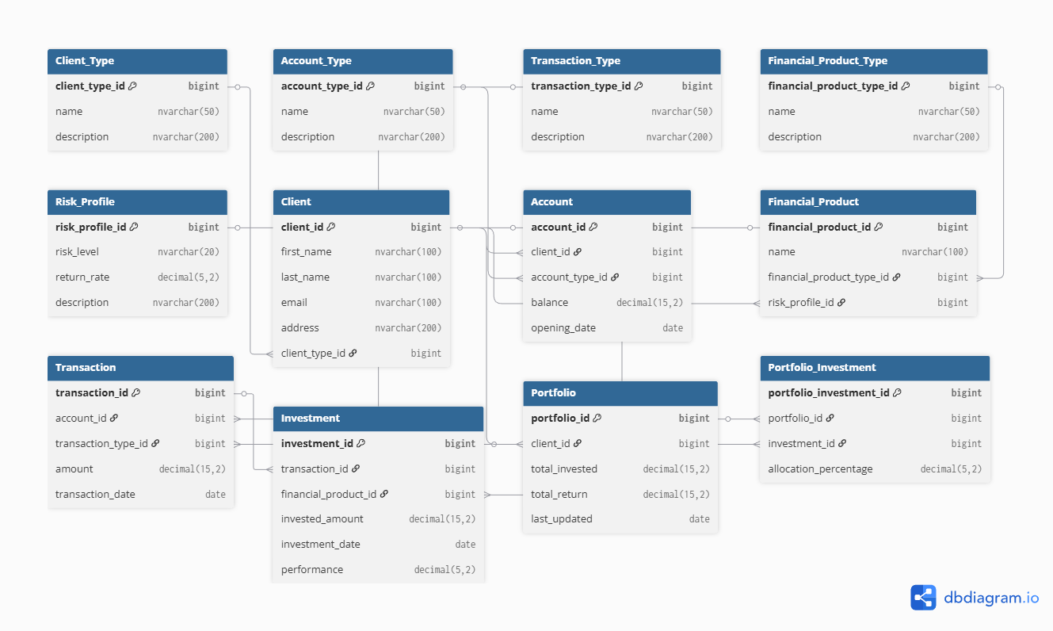

4. Tables

Reference Tables

These tables provide static or slowly changing data that drive business rules. They ensure consistency across the system.

- Client_Type
  - Purpose: Stores types of clients (e.g., Regular, Premium, Business).
  - Why needed: Different client types may have different privileges, fees, or investment options. Using a reference table avoids hardcoding these rules and ensures consistent data.
- Account_Type
  - Purpose: Defines account categories (e.g., Checking, Savings, Investment).
  - Why needed: Standardizes the account types offered by the business and allows accounts to reference them consistently for reporting, fees, and operations.
- Transaction_Type
  - Purpose: Lists types of transactions (Deposit, Withdrawal, Transfer).
  - Why needed: Ensures that every transaction has a valid type, enabling proper reporting and business logic (e.g., distinguishing deposits from withdrawals).
- Financial_Product_Type
  - Purpose: Categorizes financial products (Stock, Bond, Mutual Fund).
  - Why needed: Helps organize products by type for reporting, portfolio management, and investment strategy decisions.
- Risk_Profile
  - Purpose: Stores risk levels and expected return rates for investments (Low, Medium, High).
  - Why needed: Supports investment decisions and portfolio recommendations by linking products to risk levels. Ensures consistent application of risk metrics.

Category / Parent Tables

These tables store core business entities.

- Client
  - Purpose: Stores client details including name, email, address, and client type.
  - Why needed: Central entity for all financial operations; all accounts, transactions, investments, and portfolios are linked to clients. Serves as the anchor for reporting and analysis.
- Account
  - Purpose: Stores financial accounts associated with clients, including balance, type, and opening date.
  - Why needed: Tracks the financial resources of clients. Allows transactions to be associated with specific accounts for accurate recordkeeping and reporting.
- Financial_Product
  - Purpose: Contains all available financial products and their associated type and risk profile.
  - Why needed: Enables the system to track what products clients can invest in. Links investment opportunities to their risk and type, supporting portfolio management and reporting.

Data / Child Tables

These tables track dynamic business transactions and investments.

- Transaction
  - Purpose: Records all deposits, withdrawals, and transfers for accounts.
  - Why needed: Provides an auditable history of account activity. Supports financial analysis, statements, and reporting by type and date.
- Investment
  - Purpose: Tracks individual investments made by clients in financial products.
  - Why needed: Connects transactions to specific financial products. Allows calculation of invested amounts and performance metrics for portfolio management.
- Portfolio
  - Purpose: Summarizes a client’s overall investments and returns.
  - Why needed: Provides a high-level view of a client’s investment holdings and performance, enabling reporting and portfolio analysis.
- Portfolio_Investment
  - Purpose: Links specific investments to portfolios and defines allocation percentages.
  - Why needed: Supports diversified portfolios by showing how investments are distributed. Enables detailed portfolio-level reporting and calculations of returns and risk.

Summary
- Reference tables: Ensure consistent business rules across the system.
- Category tables: Store core entities like clients, accounts, and products.
- Child/data tables: Track transactions, investments, and portfolios over time.
- Relationships: The database structure ensures referential integrity, prevents orphan records, and supports complex queries for reporting and decision-making.

